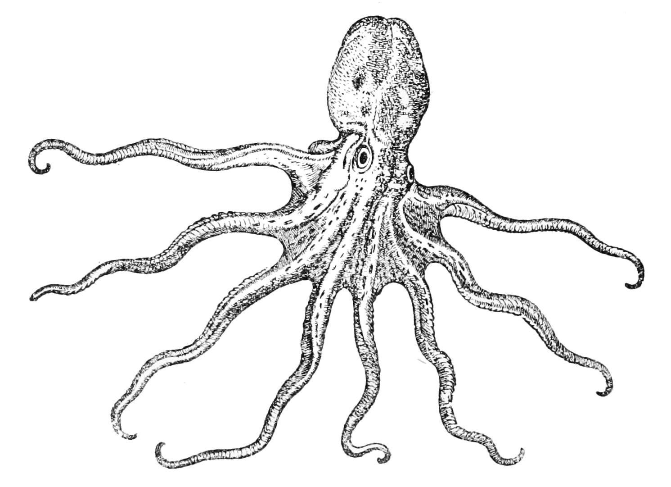Scary Invertebrate Poster Assignment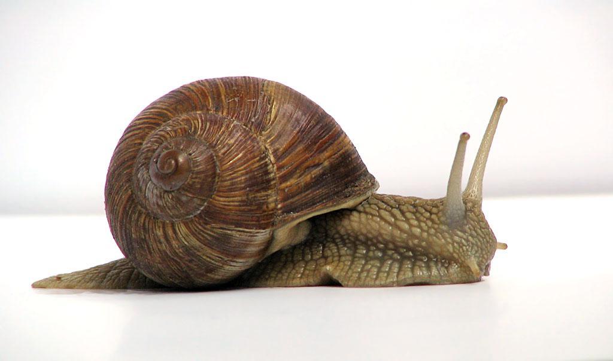

You have been hired as a zoologist for the NSA (National Security Agency) and been charged with warning the public about a possible invasion of 1 of the evil invertebrates listed below. Your assignment is to create a poster educating the general public (non-zoologists) about your chosen invertebrate.

To be included on your poster:
- An image of your fatal invertebrate.
- Where it is found.
- Why it should be avoided. What makes it so scary. Be specific about the pathology of what the invertebrate could do to a living thing.
- Which classification of invertebrate is it? (mollusc, arthropod,isopod, cnidarian, etc.)
- Creativity and scariness along with legibility and proper spelling should be paid attention to.

Aficanized Honey Bees (Killer) | Bot Flies | Army Ants (Eciton Burchelli) | Tapeworm | Bullet Ants
White Tail Spiders | Mantis Shrimp | Box Jellyfish | African Assasin Bugs | Japanese Spider Crab
Mosquitos  (Diseases) | Bathynomous (Giant Isopod) | Goliath Bird Eating Spider | Asian Giant Hornet | Giant Centipede
Colossal Squid | Death Stalker Scorpion | Marbled Cone Snail | Blue Ringed Octopus | Mongolian Death Worm
Brazilian Wandering Spider | Siafu Ants | Kissing Bugs (Diseases) | Portuguese Man o’ war | Crown of thorns starfish

