Name______________________________________ Period___________________ Date___________
Keep this paper to turn in on presentation day.
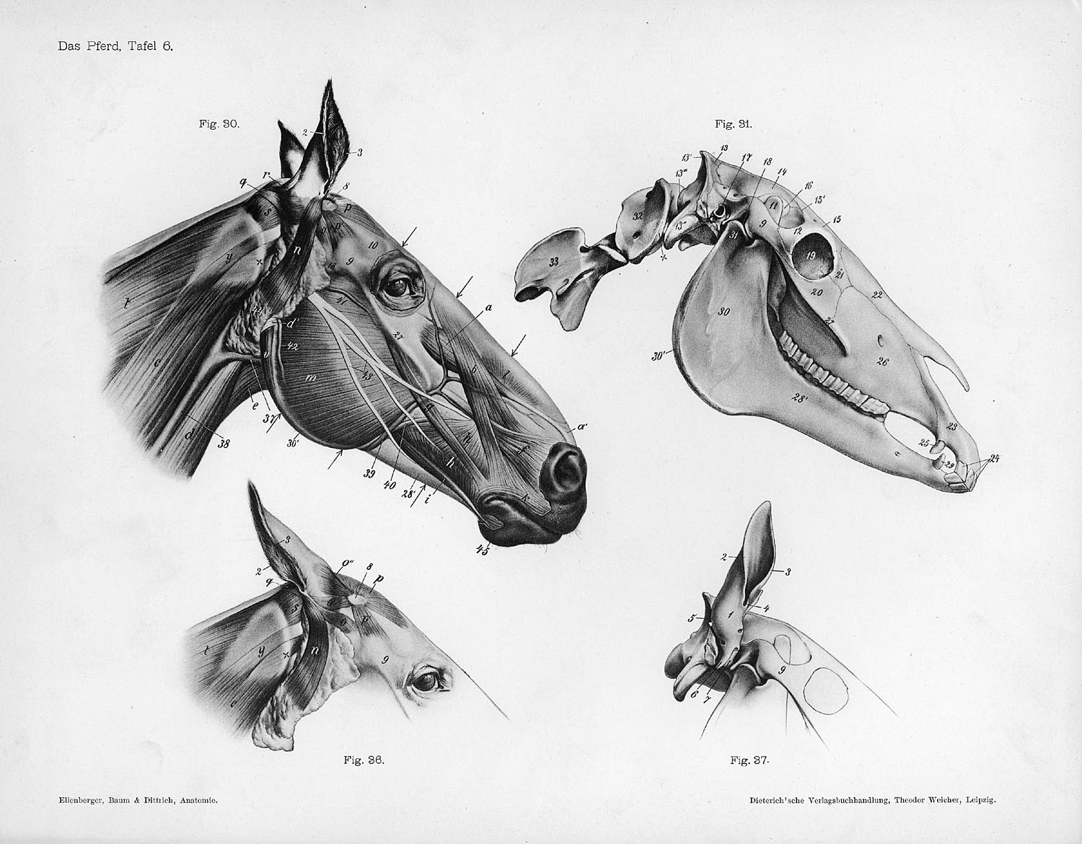Comparison of Animal Anatomy Group project
The animals to be compared are; giraffe, bat, frog, turtle, bird, fish
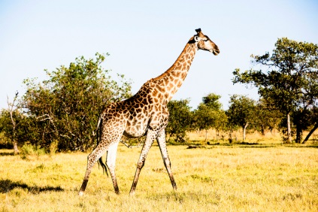 | 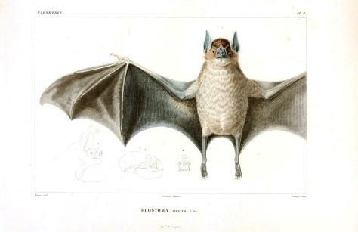 | 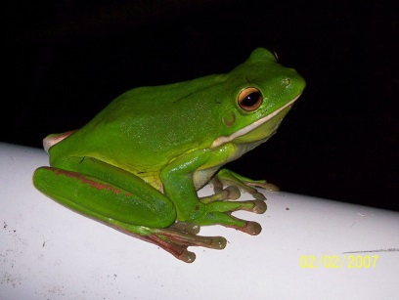
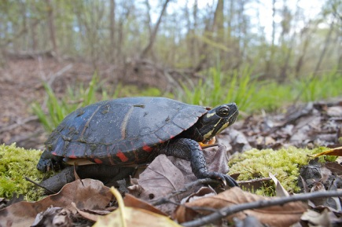 | 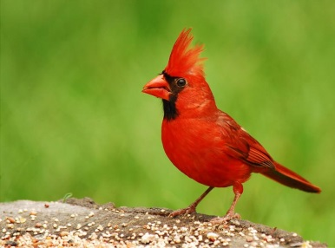 | 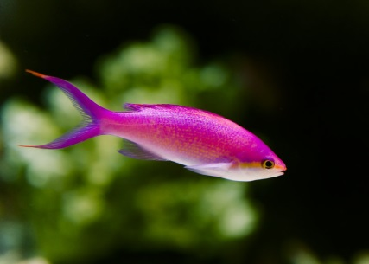
Objective: Your group will be assigned an organ or organ system. As a group you will present using 3D models and posters on your assigned organ system for each of the vertebrate animals above. You should point out specific differences in function, size, purpose and location in each animal. Clarify any differences between them.
Organ systems- Your group will have only 1 to focus on and present in a poster share.
Digestive tract | Heart-Circulatory | Lungs | Stomach
Skin and excretory | Reproductive | Visual/Hearing | Nervous

Rubric- Each group will have 3-4 people in it. Each person is expected to contribute to the project and work collaboratively.
 | points
Attendance all days | /5
Participation in your given role | /5
Creativity and accuracy of poster and model | /5
Collaboration during group work. | /5
Demonstration of knowledge during poster share | /5
Total /25
