I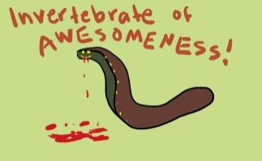Leeches: Vampires of the Worm World – Go to the below websites and summarize what you see on each. Write a 1 sentence response to each one and compare the contents of the sites. This means at least 4-6 sentences per site.
http://www.pbs.org/wnet/redgold/basics/leeches.html
http://www.naturenorth.com/fall/leeches/Leeches_2.html
http://www.pbs.org/wnet/nature/bloodysuckers/leech.html

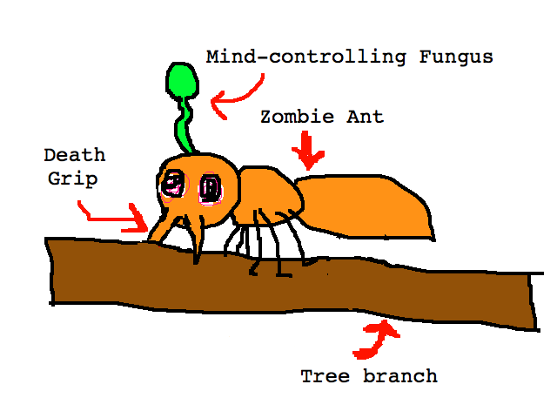Ant zombies
http://www.wired.com/wiredscience/2013/09/absurd-creature-of-the-week-zombie-ant-fungus/
http://news.psu.edu/story/277383/2013/05/21/research/getting-bottom-zombie-ant-phenomenon
http://metro.co.uk/2013/06/12/zombie-ants-fungus-the-last-of-us-playstation-3-3836808/

