**Dress like your favorite Invertebrate Halloween Assignment**.

C:\Users\deborah.chabi\AppData\Local\Microsoft\Windows\Temporary Internet Files\Content.IE5\XPG1DTOL\MC900120813[1].wmfC:\Users\deborah.chabi\AppData\Local\Microsoft\Windows\Temporary Internet Files\Content.IE5\Q0Y0ZIXA\MC900057341[1].wmfC:\Users\deborah.chabi\AppData\Local\Microsoft\Windows\Temporary Internet Files\Content.IE5\XPG1DTOL\MC900157167[1].wmfC:\Users\deborah.chabi\AppData\Local\Microsoft\Windows\Temporary Internet Files\Content.IE5\XCC3IU6P\MC900434569[1].wmf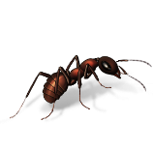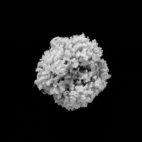C:\Users\deborah.chabi\AppData\Local\Microsoft\Windows\Temporary Internet Files\Content.IE5\Q0Y0ZIXA\MM900283578[1].gif

Halloween is quickly approaching and we need to do some assignments related to it. There will be 2 of them. The first is to dress like your favorite invertebrate.

This will be a 15 point assignment. Not extra credit like the video said.

Your grade will be based on the accuracy of your costume also for 2 minutes you need to talk about your invertebrate in first person. Extra credit will be awarded to the most entertaining costumes.

<http://www.youtube.com/watch?v=7WCPlGY4yHU>