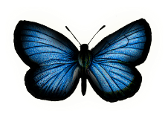Dough Invertebrates 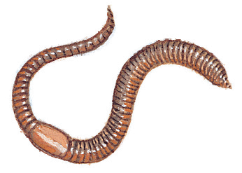
The class will divided into teams. Each team will be responsible for making a dough or clay model of a specific Invertebrate Animal as well as reporting on the Phylum and specific animals characteristics.
The dough is to be made at home, outside of class. If your team chooses you may, on your own purchase Playdough. Class time (4 periods) is to be used to research and organize your information, prepare your models, and ask questions about your model or invertebrate. The 5th class day will be used to report and show your model of your invertebrate to the rest of the class.
Grade Requirements
- A dough model of your invertebrate & identification of major structures.
- A poster as a visual aid for characteristics, etc.
- An oral presentation in the invertebrate share.
- Documentation of your specific role or job in the team (document any job you do for the team, no matter how insignificant it may seem, there is an individual grade assigned.)
Model
- No larger than 2 feet or 60cm.
- Stiff base, such as a cookie sheet or pie pan or thick cardboard.
- Different colors representing significant body sections and structures for identification.
- SHOULD include more than one model; an external and internal model OR cutaway model.
- All significant anatomical structures must be labeled with toothpicks and flags for identification and shown to the class.
- Quality of work is important!
Poster or visual aid
Need to include all the below 1-6:
- Identify Phylum through Genus and species.
- Characteristics that put the animal in that specific phylum.
- Characteristics that put the animal in that class.
- Characteristics that put the animal in that order or Genus species.

- Any other significant information your team feels necessary to identify your animals specific characteristics and classification.
- All materials are to be obtained by the group.
Presentation Day
- Every person on the team must say something.
- One missed day is a deduction from the project, miss 2 days and you are on your own.
- Poster or visual aid must be complete, with all required information, neatly done, spelling and accuracy as well as organization will be checked.

Play dough recipes can be found here.
http://fun.familyeducation.com/sculpting/recipes/37040.html

